Android System：

Transfer the file keyes wifi.apk to your cellphone or ipad. Click keyes wifi.apk to install.
Click“ALLOW”and“INSTALL”
After installing, click“OPEN”to check the main page of app
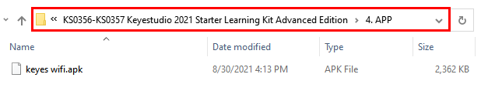


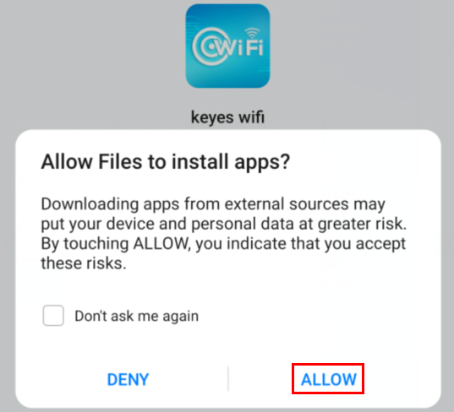

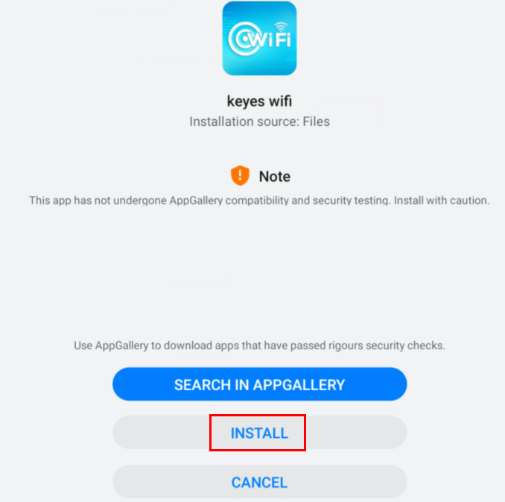
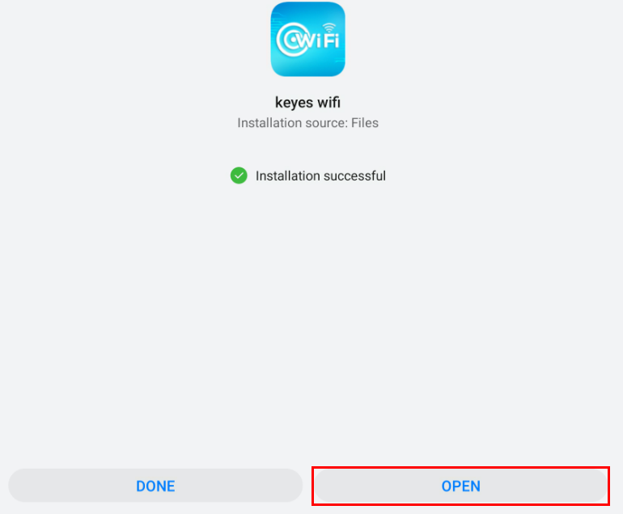

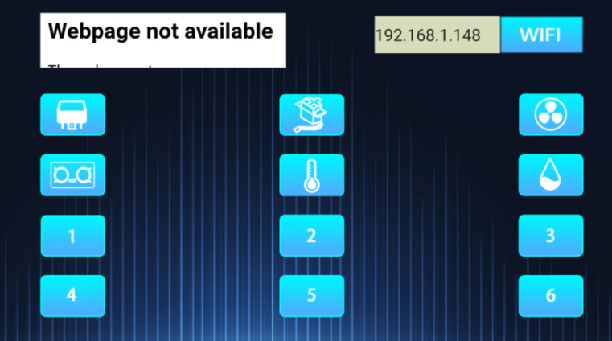

iOS System
- Open App Store

Search keyes wifi to download.

